Steps for Online Fees Payment
- Visit School Website www.aggarsainpublicschool.ac.in
- Click on Online Fees Payment
- Enter your User Name and Password then click OK button.
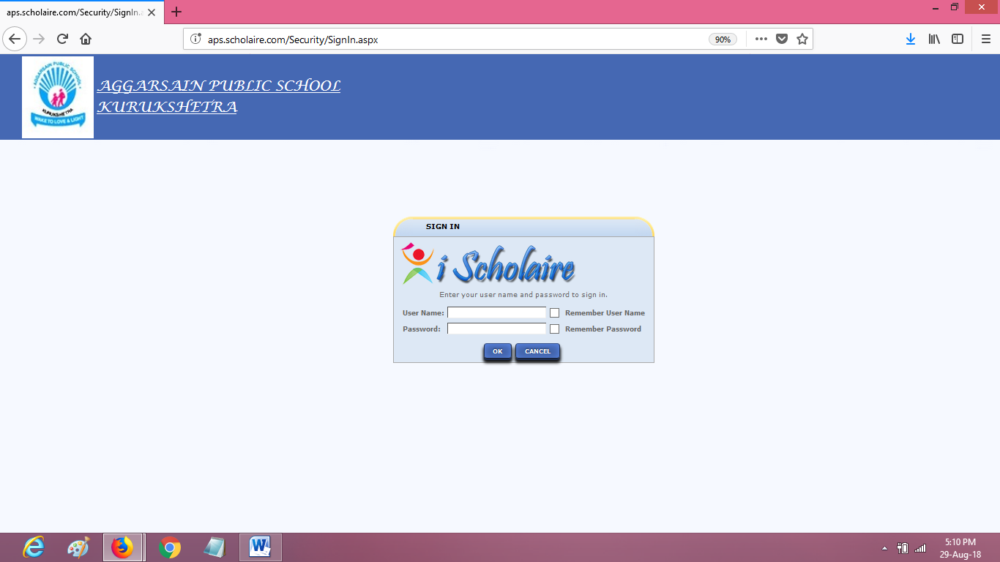
- Click on the Icon – Fees Payment or Menu – Fees Payment Student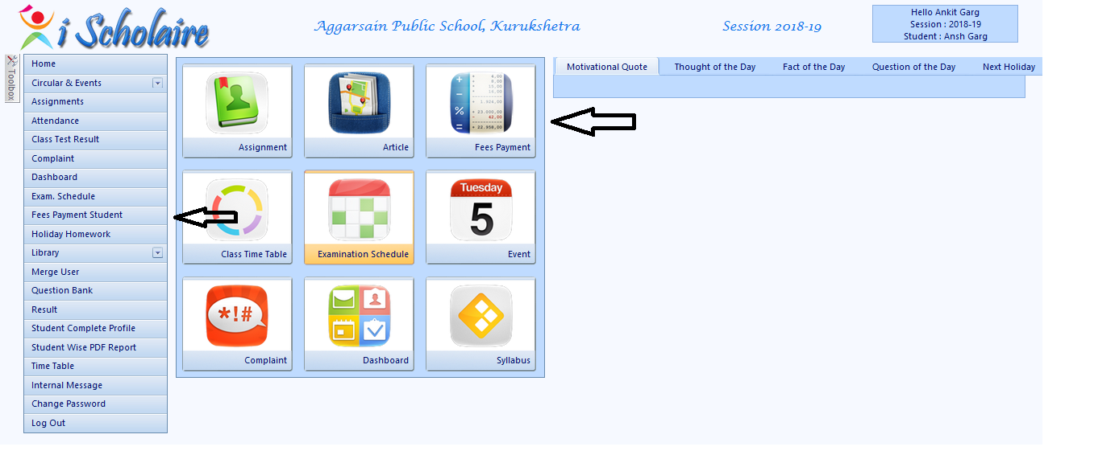

- Select the period for which you want to pay the fees
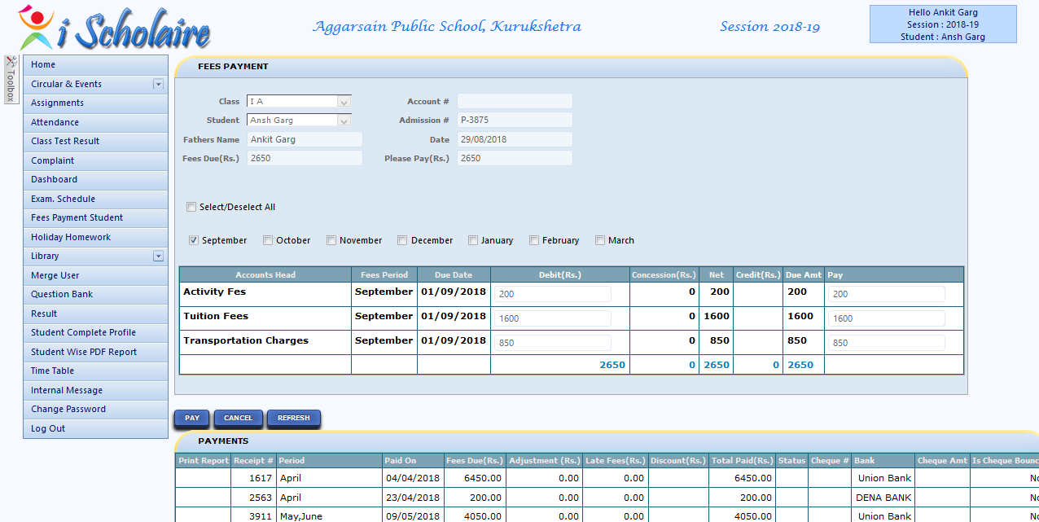
- Click on Pay
- Enter your details of (Credit Card, Debit Card, Net – Banking)

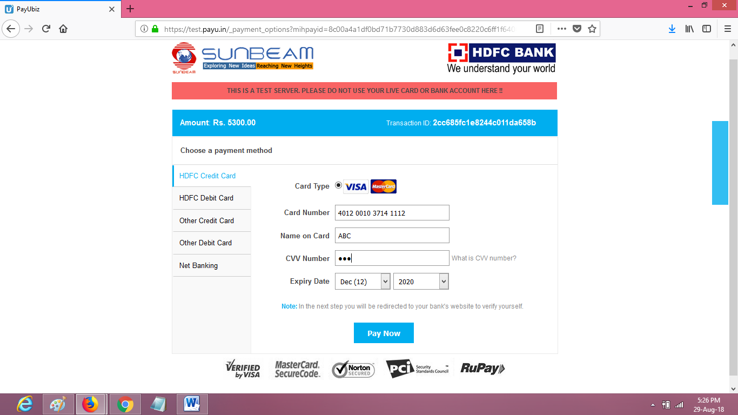

- After Payment you will find Receipt

